PIANO METHOD BOOKS
Instructors, please circle which book your student needs as they progress

An instructor will inform you of what book you will need. These books are available on Amazon or SheetMusicPlus. If you would like to support locally, Ted Brown Music should have these in stock.

If you have any questions email music@ or your instructor. Congratulations on your student beginning music or graduating their book!

Bastien Piano Basics

* Primer Level A
- Piano (ISBN: 0849793173)
- Theory & Technic (ISBN: 084979319X)

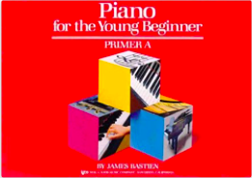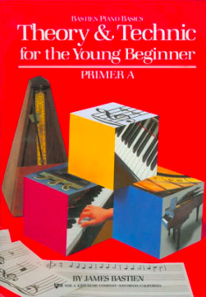

* Primer Level B
- Piano (ISBN: 0849793181)
- Theory & Technic (ISBN: 0849793203)

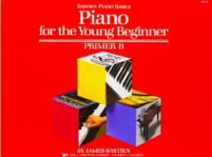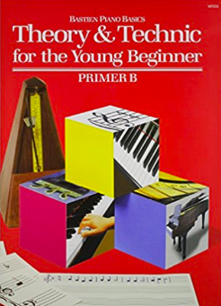

* Piano Primer Level (ISBN: 0849752655

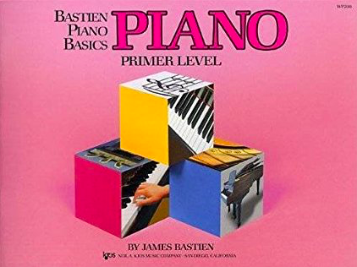

* Piano Level 1 (ISBN: 0849752663)

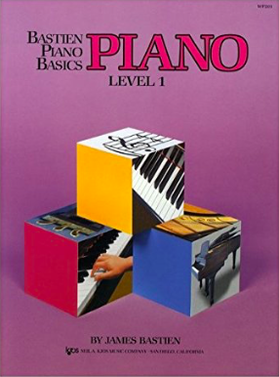

* Piano Level 2 (ISBN: 0849752671)

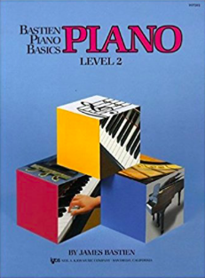

* Piano Level 3 (ISBN: 084975268X)

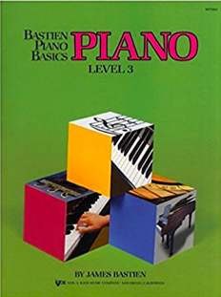

* Piano Level 4 (ISBN: 0849752698)

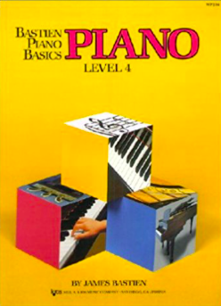

Nancy and Randall Faber Piano Adventures

* Primer Level (ISBN: 1616770759)

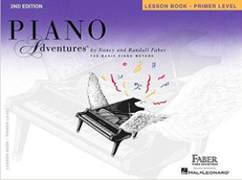

* Level 1 (ISBN: 1616770783)

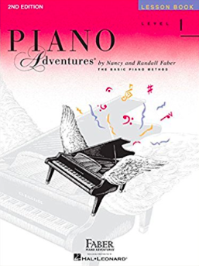

* Level 2A (ISBN: 0929666623)

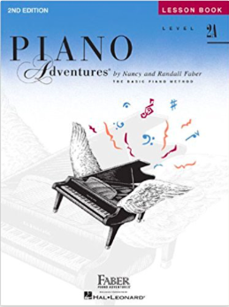

* Level 2B (ISBN: 1616770848)

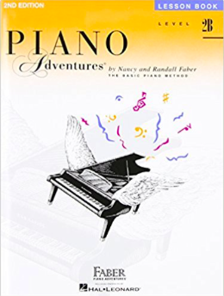

* Level 3A (ISBN: 1616770872)

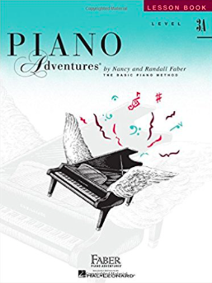

* Level 3B (ISBN: 1616771801)

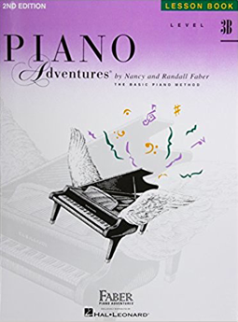

* Level 4 (ISBN: 1616770902)

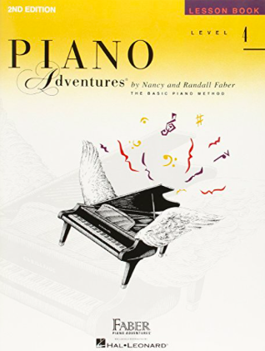

* Level 5 (ISBN: 1616770937)

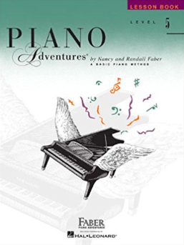

Junior Hanon (ISBN: 0739012908)

